**2.0 SYSTEM ANALYSIS AND DESIGN**

*1.1.1 Identification of SAD Methodology*

For this project, we will use a **Structured Analysis and Design (SAD) approach** combined with **Iterative SDLC**.  
This approach is chosen because:

* It focuses on understanding requirements through data flow and user interaction.
* It allows breaking the project into logical steps: analysis, specification, logical design, and physical design.
* It ensures user feedback is considered at every stage, improving the final system.

*1.1.2 Analysis of the existing system*

Currently, Hotel Lillies operates using a combination of manual and semi-digital processes. Reservations for rooms, dining, and events are made in person or via phone calls, with records stored on paper or simple spreadsheets. Menu and pricing information is not easily accessible to customers unless they visit the hotel or make direct inquiries. This results in limited customer reach, frequent booking errors, and inefficient communication between staff and guests.  
  
Additionally, there is no centralized platform for tracking bookings, generating reports, or handling customer inquiries in real time. These limitations create delays, miscommunication, and reduced customer satisfaction, highlighting the need for a modern Hotel Management System website with integrated chatbot support.

*1.1.3 System requirement specification*

**System Requirement Specification** defines what the Hotel Management System should do and how it should perform. It includes both functional requirements and non‑functional requirements.

***Functional Requirements***

The functional requirements of the Hotel Management System outline the key features and capabilities that the system must provide to effectively address the operational challenges at Hotel Lillies. These requirements focus on the following:

1 Allow customers to make reservations for rooms, dining, and events online.  
2 Display real-time menu items, pricing, and available services.  
3 Provide chatbot-based assistance for answering inquiries and guiding bookings.  
4 Maintain a centralized database for customer profiles, bookings, and service history.  
5 Generate reports on bookings, payments, and customer feedback.  
6 Send automated booking confirmations and reminders via email or SMS.  
7 Allow customers to submit feedback online.

***Non‑Functional Requirements***

In addition to the core functions, the Hotel Management System must also meet several non‑functional requirements. These define the quality attributes of the system, such as performance, usability, security, and scalability, to ensure the system operates smoothly and provides a positive user experience.

1 Performance: The website must respond to customer requests quickly, even during high traffic.  
2 Usability: The interface should be simple, intuitive, and accessible on both desktop and mobile browsers.  
3 Security: Sensitive data must be encrypted and protected from unauthorized access.  
4 Reliability: The system must operate 24/7 with minimal downtime.  
5 Scalability: The platform should handle increasing data and traffic as the hotel expands.

***1.1.4 LOGICAL DESIGN***

The logical design of the proposed Hotel Management System provides an abstract representation of how different users and components of the system will interact without focusing on technical implementation. It focuses on modeling user interactions, data flow, andsystem behavior in a clear and structured way.

For this project, the logical design will represent how customers will use the website and chatbot to view menus, check room or event availability, and make bookings. Hotel staff will access a secure dashboard to confirm reservations, update availability, and view customer feedback. Management will generate reports and monitor service performance through administrative tools.

* ***Use case diagram***

The use case diagram illustrates how different users will interact with the Hotel Management System website with integrated chatbot support. It identifies four main actors: Customers, Hotel Staff, Management, and the Chatbot System, and shows the core services they access.

* Customers can browse menus and prices, make reservations for rooms, dining, or events, interact with the chatbot for inquiries, receive booking confirmations, and submit feedback.
* Hotel Staff can confirm or update bookings, manage menu and room availability, and view assigned tasks through the system.
* Management can generate booking and service reports, monitor operational performance, and review customer feedback.
* The Chatbot System assists customers with real-time responses, guides them through the booking process, and collects basic information for staff follow-up.

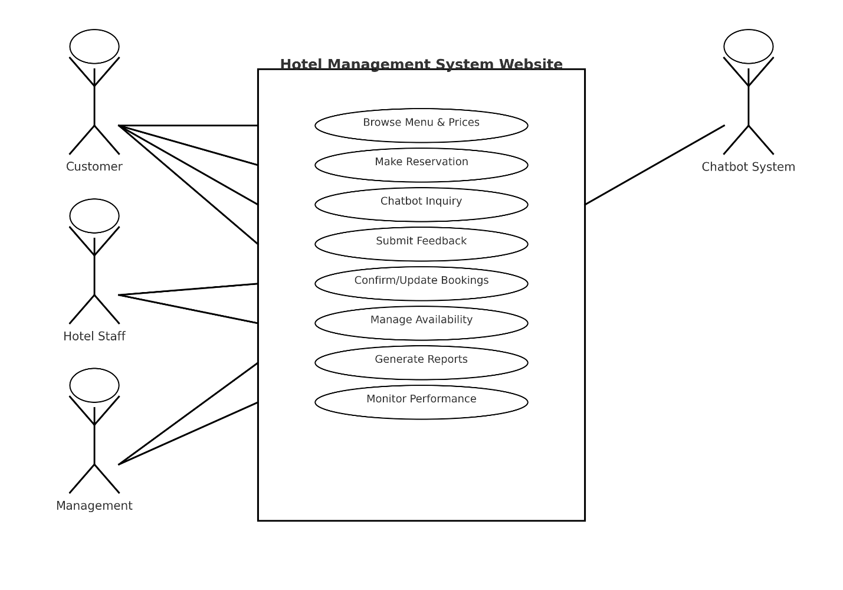

**Context Diagram**  
The context diagram below provides a high-level view of the Hotel Management System as a single process.  
It illustrates how customers, hotel staff, management, and the chatbot interact with the system, and how data flows between these users and the central database. The diagram highlights key exchanges such as booking details, payments, confirmations, reports, and service updates, showing the overall scope of the system before moving to detailed design.

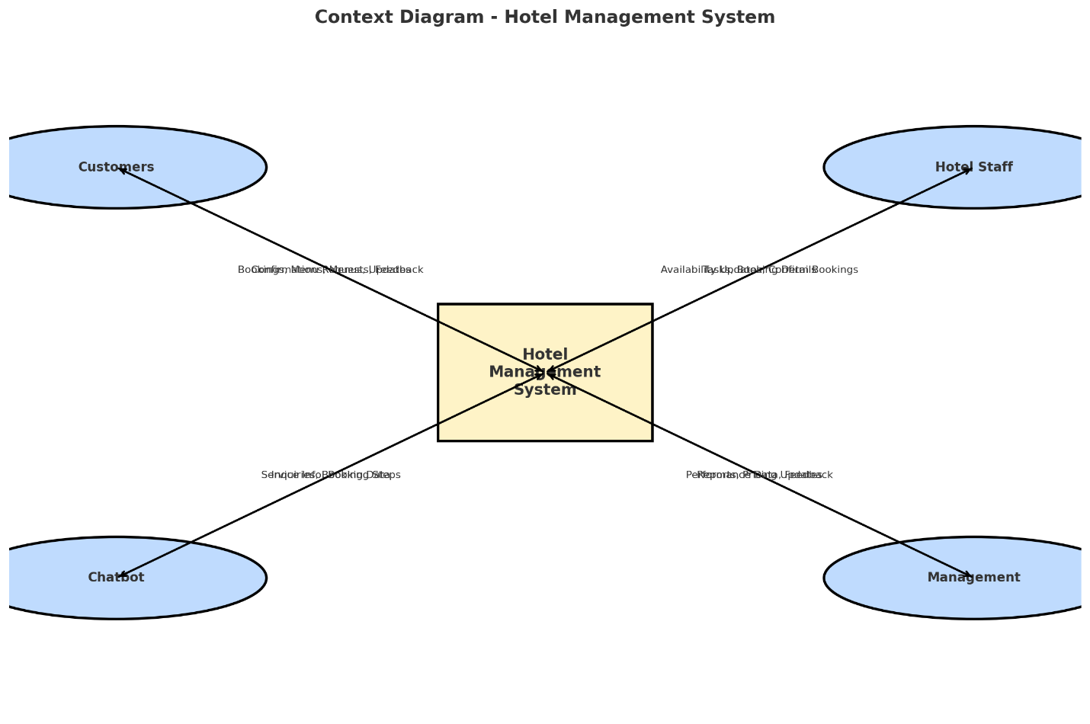

**Inputs**

* **From Customers:** Booking details (room, dining, event), contact information, payment details, and feedback.
* **From Hotel Staff:** Room availability updates, menu updates, and task assignments.
* **From Management:** Operational decisions, pricing updates, and promotional packages.
* **From Chatbot:** Customer inquiries and collected booking data.

**Processes**

* The system receives data from different users, validates it, stores it in the central database, and sends the appropriate responses (e.g., confirmations, reports, updates).

**Outputs**

* **To Customers:** Booking confirmations, receipts, reminders, and service information.
* **To Hotel Staff:** Task lists, updated booking schedules, and customer requests.
* **To Management:** Reports on bookings, finances, customer feedback, and performance.
* **To Chatbot:** Processed responses to inquiries and real-time booking assistance.

**Data Flow**

* Data flows between users and the system in both directions — inputs are sent to the system, processed, and corresponding outputs are delivered to the correct actor.

**Level1 Data flow diagram**

The Level 1 Data Flow Diagram expands the single process shown in the context diagram into detailed sub-processes.  
It shows how booking, check-in/check-out, billing, and feedback processes interact with the central database. The diagram also illustrates the flow of data between customers, hotel staff, management, and the chatbot, providing a clearer picture of how the system operates internally.

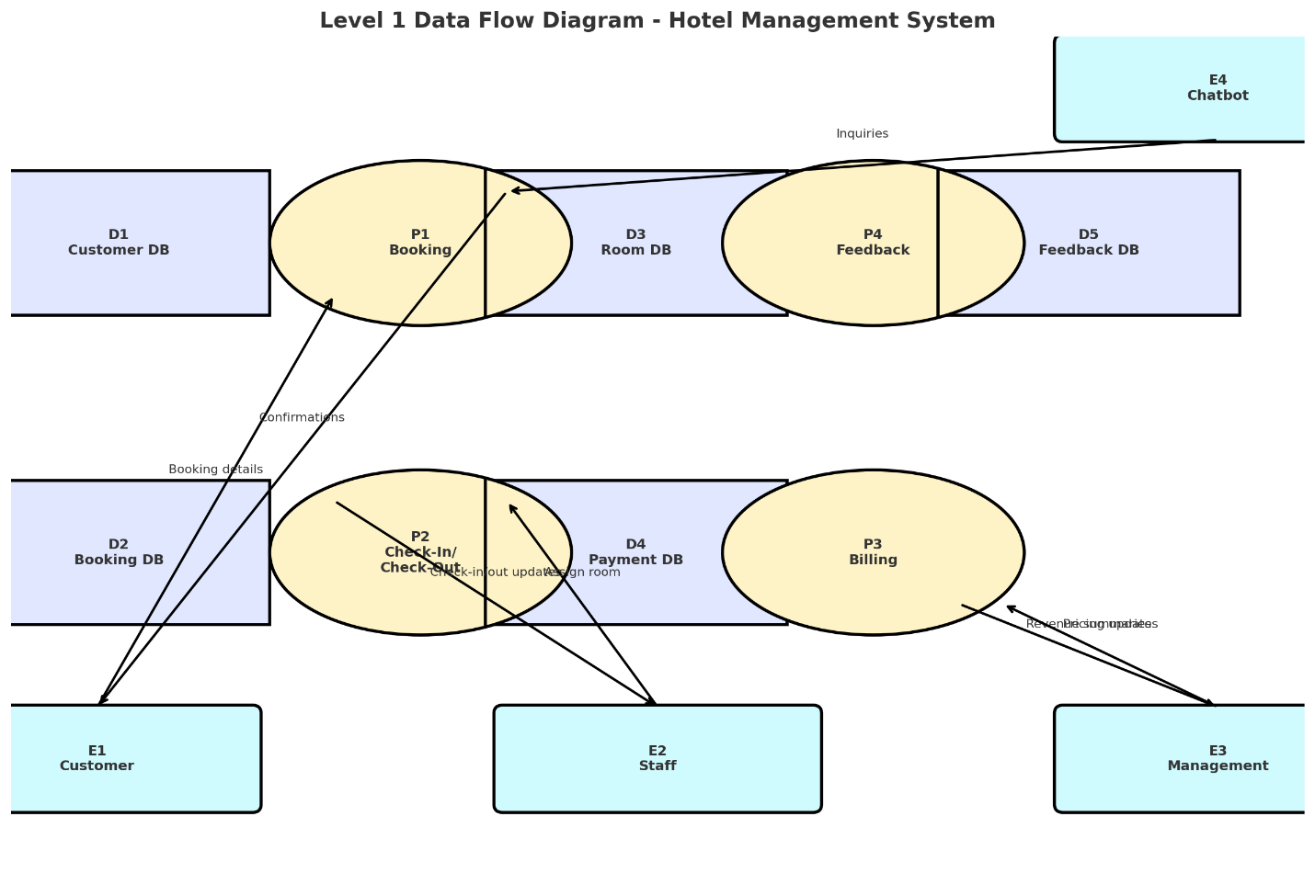

**Processes**

1. **Booking Process** – Captures booking requests from customers (rooms, dining, events) and stores them in the database.
2. **Check-In/Check-Out Process** – Updates room availability and guest stay records.
3. **Billing Process** – Calculates costs, processes payments, and generates receipts.
4. **Feedback Process** – Collects customer feedback, stores it in the database, and makes it available for management review.

**Data Stores**

* **Customer Database:** Stores customer profiles and contact information.
* **Booking Database:** Stores details of all reservations.
* **Room Database:** Stores room types, availability, and pricing.
* **Payment Database:** Stores payment transactions.
* **Feedback Database:** Stores customer comments and ratings.

**Inputs & Outputs**

* Inputs: Booking details, payment information, feedback forms, staff updates.
* Outputs: Confirmation messages, updated room schedules, payment receipts, and performance reports.
* ***Entity Relationship Diagram***

The Entity Relationship Diagram (ERD) presents the main data entities in the Hotel Management System and the relationships between them.  
It defines how customers, bookings, rooms, payments, staff, feedback, and reports are linked within the database. This diagram ensures that the system’s data is well-structured, eliminates redundancy, and supports efficient retrieval for reporting and operations.

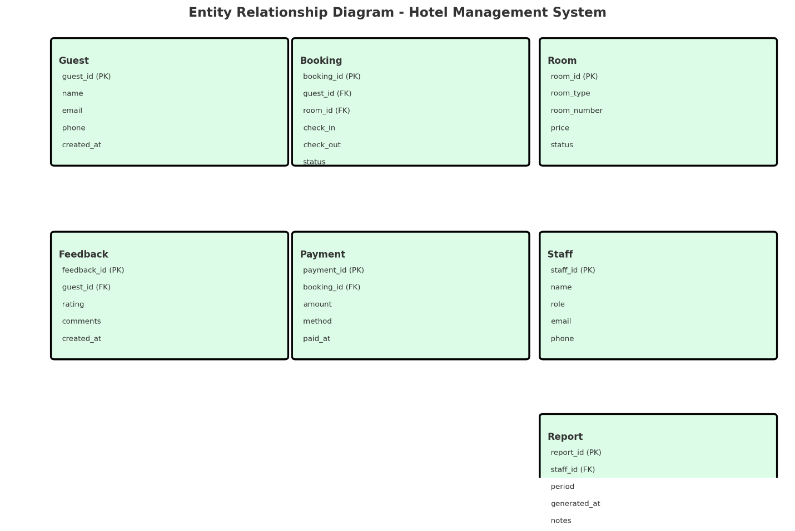

**Main Entities & Relationships**

* **Guest – Booking (1: N):** Each guest can make many bookings; each booking belongs to one guest.
* **Booking – Room (1: N):** A booking can include one or more rooms; each room booking is tied to a single booking.
* **Booking – Payment (1:1):** Each booking has exactly one payment record.
* **Guest – Feedback (1: N):** Guests can submit multiple feedback entries; each feedback is linked to one guest.
* **Staff – Report (1: N):** Staff can generate many reports; each report belongs to one staff member.
* **Booking – Report (1: N):** Reports can contain data from multiple bookings; each booking can appear in multiple reports.
* **Staff – Room (1: N):** Staff manage multiple rooms; each room is managed by one staff member at a time.

**Purpose**

* Ensures all hotel operations data is linked correctly, avoids duplication, and supports accurate reporting.

***1.1.5PHYSICAL DESIGN***

The physical design of the Hotel Management System focuses on how the system will operate in a real environment. It specifies how data will be captured, processed, stored, and presented to users, while also ensuring system security, reliability, and regular backups. This design bridges the gap between the logical design and actual implementation, ensuring that the solution runs efficiently and meets the operational needs of Hotel Lillies. The physical design includes the **user interface design** and **process design**.

***Input Requirements***

The system will capture data according to each user’s role:

* **Customer booking forms** (web-based) for rooms, dining, and event reservations.
* **Staff interfaces** for updating availability of rooms, menus, and event schedules.
* **Payment entry forms** integrated with secure online payment gateways.
* **Feedback forms** submitted by customers after using the hotel’s services.
* **Chatbot interaction logs** for handling inquiries and pre-booking guidance.

Output Requirements

The system will provide outputs in accessible formats for ease of use:

* **Digital booking confirmations** and receipts for customers.
* **Real-time dashboards** for staff showing bookings, availability, and assigned tasks.
* **Automated management reports** on occupancy, revenue, and service feedback.
* **Notifications and alerts** sent via email or website pop-ups for booking updates and reminders.

*Data Storage Requirements*

The system will securely store and organize all hotel operational data:

* A **centralized MySQL database** hosted on a secure web server.
* Separate tables for customers, bookings, rooms, payments, services, feedback, staff, and reports.
* Regular indexing and optimization for quick data retrieval*.*

*Processing Requirements*

The system will handle the following processes:

* **Real-time processing** of bookings, payments, and availability updates.
* **Automated billing** and generation of management reports.
* **Chatbot-assisted inquiry handling** to streamline customer interactions.

***System Control and Security***

To ensure secure and reliable operation, the system will include:

* **Role-based authentication** (Admin, Staff, Customer).
* **Secure data transmission** using SSL encryption.
* **Access logs and audit trails** to track system activity.

***System Backup and Recovery***

The system includes automated daily backups and recovery procedures to ensure that hotel data is never lost. In case of a failure, the system can quickly restore bookings, payments, menus, and guest records, keeping operations running smoothly.

* **Automated Backups:** Daily automatic backup of all hotel data (bookings, menus, payments, guest records, staff schedules).
* **Cloud & Local Storage:** Backup files stored both locally and in the cloud for extra safety.
* **Quick Recovery:** Simple restoration process in case of system failure or data loss.
* **Data Security:** All backup data is encrypted using secure methods to protect sensitive guest and hotel information.

***1.User interface design***

The user interface for the Hotel Management System is designed to be simple, clear, and easy to navigate. It provides three main views:

* **Customer Booking Interface:** For customers to browse menus and prices, interact with the chatbot for inquiries, and make reservations for rooms, dining, or events, with integrated payment options.
* **Staff Dashboard:** For hotel staff to manage room and event availability, confirm bookings, and track assigned tasks.
* **Admin Dashboard:** For hotel management to generate reports, monitor bookings and revenue, review customer feedback, and update service information.

These interfaces feature clear menus, well-organized layouts, and mobile-friendly responsiveness to ensure ease of use on desktop and mobile browsers. The design focuses on reducing confusion, saving time, and providing an engaging experience for all users.

***User interface workflow diagram***

The workflow diagram below illustrates how different users interact with the Hotel Management System website. It shows the main entry point (home page) and how customers, hotel staff, and management navigate to their respective sections.

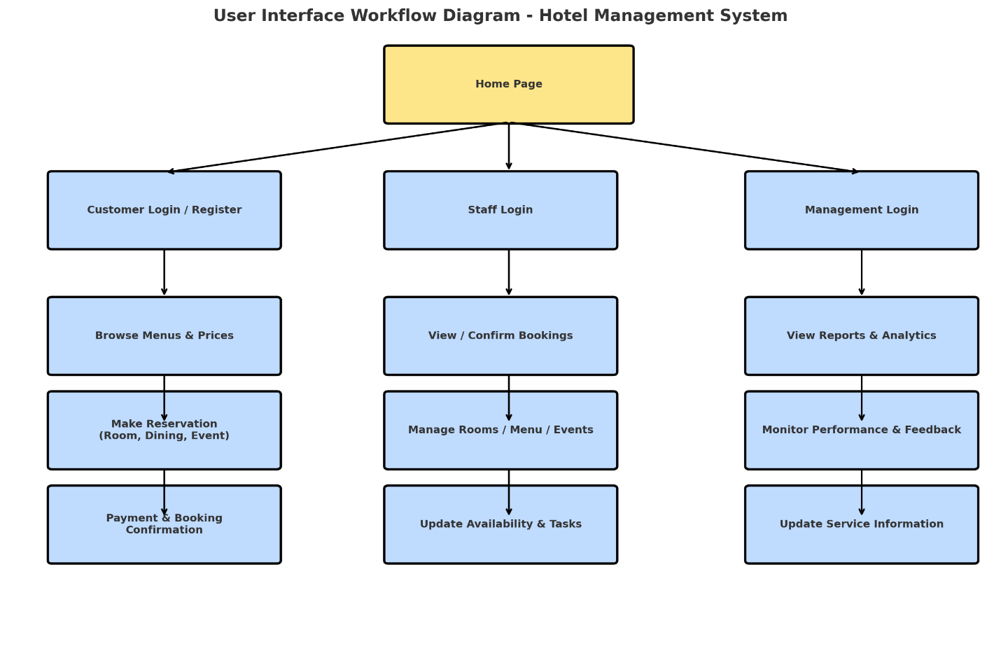

* **Customers** can browse menus and prices, interact with the chatbot for inquiries, make reservations for rooms, dining, or events, and complete payments online.
* **Hotel Staff** can log in to confirm bookings, update availability, and manage assigned tasks.
* **Management** can access reports, update service information, and monitor hotel performance.

This structure ensures that each user group has clear access to the features designed for their role, improving organization, efficiency, and the overall customer experience

***2.Process design***

The process design defines how data moves through the Hotel Management System and how different processes are executed. It focuses on validating, securing, and organizing information as it flows into, through, and out of the system.

The diagram for the Hotel Management System illustrates the key processes, starting from user login to backup and recovery of data.

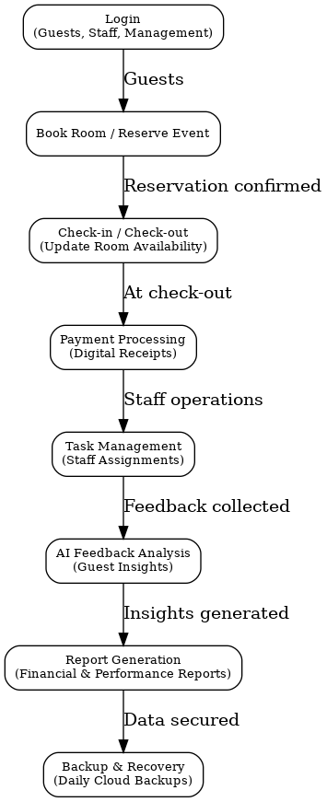

***Process Explanation***

**Key Areas of Process Design**

* **Login:** Customers, staff, and management access the system using secure login credentials.
* **Browse & Reserve:** Customers can browse menus, prices, room/event availability, and place reservations online.
* **Booking Management:** Staff confirm bookings, update availability, and assign related tasks.
* **Payment Processing:** Payments are securely processed and linked to booking records, with instant confirmation.
* **Feedback Collection:** Customers can submit feedback through the system after using hotel services.
* **Report Generation:** The system generates automated operational and financial reports for management.
* **Backup and Recovery:** All data is backed up daily to secure storage, with quick restoration procedures in case of system failure

***contributions***

*Racheal*

* Identification of SAD methodology
* Analysis of the existing system
* System requirement specification
* Entity relationship diagram
* Level data flow diagram
* User interface design

Stephen

* Logical design
* Use case diagram
* Context diagram
* Physical design
* Process design
* Tools used for coding and testing
* Testing strategy